IOT opdracht  
Stijn van Bolderen & Wisun Willems  
20-3-2024

Introduction:

We were tasked with making the payload encoder of the KISSLORA device smaller and, if necessary, changing the payload decoder on the thingsnetwork.

**How we approached it and why we made what choices**:

At first we tried to modify the Cayenne functions so that the size of the code on the end device was smaller but the Cayenne protocol was still preserved. After trying this, we had only saved 14 bytes. Which is almost nothing compared to the total 32KB flash of the chip. On the advice of another student, we looked into the possibility of creating a custom payload format to remove the overhead of Cayenne and save flash. This format only sent the data from the sensors instead of data type + data as in Cayenne. This was possible and we applied it. With this we saved another 630 bytes. Not much but already a lot better than 14 bytes. Because we were no longer using the Cayenne protocol, we had to write a custom payload decoder in Javascript. After looking at online examples and help from others we managed to write the payload decoder program.

Byte size original code:

Byte size code after changes:

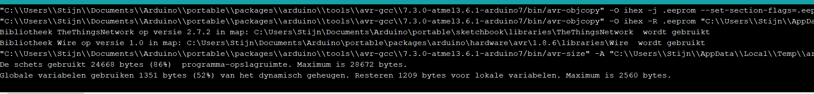

Conclusion:

We reduced the number of flash bytes used from the end device as was expected of us, but because of the payload format we applied, any change in the order of the transmitted data requires the payload decoder to be adjusted.